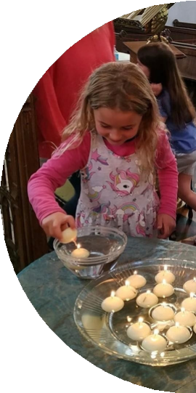




Creating a Plan for Growth
Small Group Guide

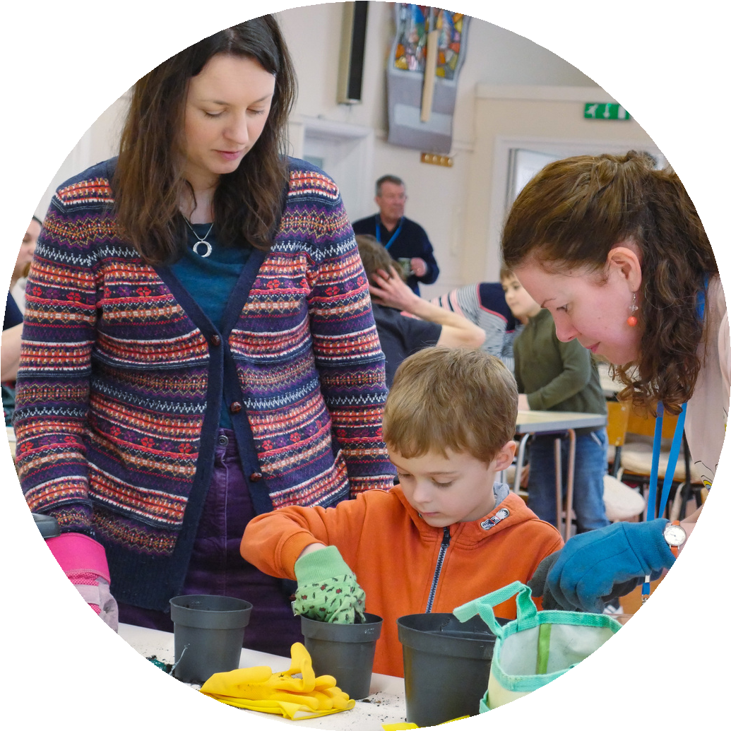



Welcome
Thank you for participating in Growing in God. This guide is a resource to help you as a Lightwave group to create your Plan for Growth. We want your Plan for Growth to be prayerfully discerned and owned by the members of your group, seeing what God is doing and discovering how to join in. You will also want to discern with other parts of the local church e.g. parish, benefice or deanery.

God is with us, gathering us as Christ-centred communities, calling us to make Christian disciples, sending us in loving service, empowering us by the Holy Spirit.

We discern that God’s desire is for us to:

to deepen our awareness of God with us through prayer and vibrant worship, centring our lives on Jesus Christ through the proclamation of the Word and the celebration of the Eucharist.


to participate in God’s loving movement towards the world in partnership with other congregations, denominations and people of good will.


to witness to the person and way of Jesus Christ, in word and worship, in service and daily life, inviting others into the fullness of life found in him.


to engage all generations, allowing them to shape how we do church and investing in them as present and future ministers of the gospel; to develop our congregations to reflect the age profile of the context in which they are set.

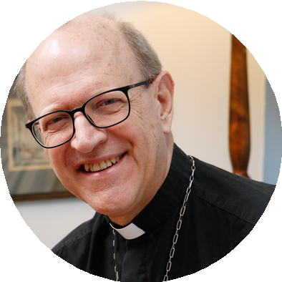
"We believe as Christians we are called to ministries of
transformation... We want to grow in whatever ways we can, to serve God in the communities we are placed."



The Rt Revd Martin Seeley
Bishop of St Edmundsbury & Ipswich

Listening for mission with your group


These resources are designed to help you to listen to God and discern what he is saying to you about your call to reach out with His love in your local area or network. Although they are arranged as 6 sessions for small groups, you could take longer than one week over some of the activities, take them in a different order and miss some out all together. There is more material than you need to use so you can pick and choose: The point is to listen to God and to respond to his call.

Page 4
Page 6
Page 7
Page 8
Page 9
Page 10
Page 11
Page 12
Page 14
360 Degree Listening - Meeting 1 Keep Listening- Meeting 2 Prayer Walking
Exploring with the eyes of faith - Meeting 3 Listening Activities
Stepping Stones for Discipleship - Meeting 4 The Suffolk Discipleship Pathway
Bringing our ideas together - Meeting 5 Preparing for Action - Meeting 6

In adapting these materials, these practices which have been adopted by Lightwave small groups are useful to bear in mind:
All Involved – Everyone in your group has a part to play and a ministry. Make sure all voices are heard and try sharing out the leadership of different parts of the sessions.
Becoming Disciples – We are all learning together to follow Jesus.
Creating Community – Act in a way which promotes love and caring, not only within your group but especially beyond it too.
Doing Evangelism – This is about being God’s good news as well as telling God’s good news. How is your group good news for your local area?

Encountering God – It is God who loves us and transforms us. Every time you meet, make sure there is time to meet with him.



360 Degree Listening
SMALL GROUP MEETING 1

Listening is an essential part of loving. As Christians, we are called to:
- Listen to God through prayer
- Listen to our Church and its traditions
- Listen to people – their hopes, fears, needs and joys
- Listen to and be aware of ourselves – our feelings and experiences

This is sometimes called 360-degree listening because we are listening all around.

Welcome
Tell the group about someone you know who is a really good listener. How has their good listening made a difference to you?

Worship
Praise God for listening to us and make some time to listen to him.
For example, play some quiet music, sit quietly as a group with your hands open and seek to receive anything God might want to show you.
Share anything which you felt God might be saying in your time of worship.

Word
Read Luke 2.41-47 and Mark 10.46-52. How is Jesus involved in listening in these passages. Who is he listening to and what difference does his listening make?

Witness
If any of you already have an idea as to what group or community God has called
you to reach out to, share this with each other now? It could be people in a particular village or workplace, people of a particular age group or people with particular needs or interests. What makes you think you may be called to reach out to this community? Watch the story of Cable Street on Youtube by clicking the link or scanning the QR code below: www.t.ly/6VSKx
Pool your ideas on how listening in different directions plays a part in the story.

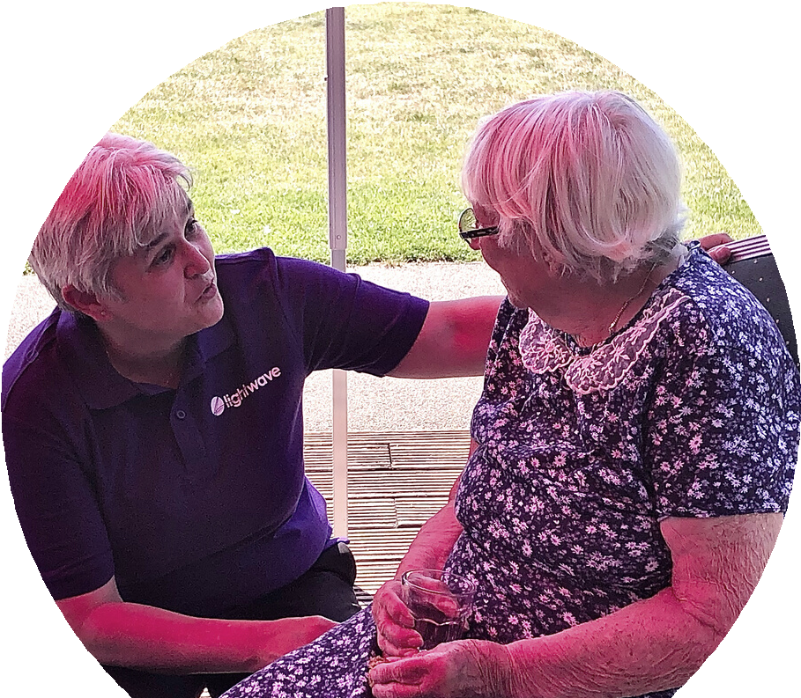





Pray together asking God to make you good listeners
PRAY

Everything we do and aspire to do needs to be soaked in prayer to change us, so that we might see as God sees and be ready to follow him wherever he
leads.

Keep Listening
SMALL GROUP MEETING 2

Welcome
Watch ‘The Story of Somewhere Else’ and see how a new community began as one minister walked the streets of Liverpool, watching, praying and listening, you can watch the video here or scan the QR code below: www.t.ly/vt0ui
Each share one thing about listening which strikes you from this story.


Worship
“What you worship as something unknown, is the One I am proclaiming to you… In Him we live and move and have our being. As some of your poets have said, ‘We are His children.’” Acts 17. 23,28
Sing (or listen to a song) to God for his greatness and his presence in all places and cultures. Then praise God for particular signs of his presence in the community to which you seek to reach out. Name individual people and places/ events and give thanks for God’s presence in each one.

Word
Read Acts 17.16-34 (Paul in Athens).
- What aspects of Athenian culture does Paul find out about?
- How does this shape his approach to sharing the message about Jesus with them?
- How does this story speak into your situation as you seek to reach a particular community/ engage in a particular project for God?
Pray for each other and about what God is saying to you.

Witness
Think again about the community you are seeking to bless and note answers to the following questions on a large sheet of paper.
- What do you think God is doing already in this community?


- Where do you think the needs are and the points of darkness or difficulty for the community you are seeking to bless?
- What gifts and resources do you bring?
- Who might your partners be? (Churches? Schools? Charities?) Pray about what you learn and keep the list for next week.







Prayer-walking

Welcome
Share anything you have learned about your community in the conversations you had this week.
Organise yourselves into pairs to walk round different parts of the area you feel that God is calling you to, praying and listening as you go.

Word and Worship
Read: Colossians 4:2-6. Praise God for the gift of prayer and pray that he will draw to your attention people and things, he wants you to notice as you walk.
Go for a prayer walk. Pray as you walk. It doesn’t matter if this is out loud or in silence. Praise God for the area through which you walk. Ask God to bless any you know who love or work or play there. Be alert to notice anything which God is drawing your attention to about the area.

Witness
Back at base, over refreshments, share and note down anything which you felt that God was drawing to your attention in your prayer-walks. Discuss and plan what to do next, do some in-depth listening to the people you are seeking to serve. See session 4 outline for ideas. Choose one or two which are most relevant to your situation or invent your own ways.

Exploring with the eyes of faith
SMALL GROUP MEETING 3

Welcome
Get a large-scale map of the local area. Take it in turns to suggest things to plot on the map – eg homes of particular team members, key meeting places of the local community. If you have been on a prayer walk, share anything to which you felt God was calling your attention.

Worship 1
Each share one thing you want to thank God for this week and one thing to pray for. Then pray together for each other and for anything which came up through the mapping exercise.

Word
Read Numbers 13 & 14.1-9 (Moses and the explorers)
How does this story speak to you? Each share a verse or something from the story which strikes you?
If it is helpful, use these questions:
Whose idea is it to send explorers? What were they to do?
Compare the responses of Joshua & Caleb and the other spies
In what ways are you like the explorers and in what ways different?

Witness
- Think about the community you are seeking to bless and note answers to the following questions on a large sheet of paper
What do you think God is doing already in this community?
Where do you think the needs are, and the points of darkness or difficulty for the community you are seeing to bless?
What gifts and resources do you bring?
Who might your partners be? (Churches? Schools? Charities?)
- Plan some listening activities. This could be prayer-walking, or have a pub meal or other informal meeting in a relaxed setting. Provide something to eat and drink and a warm welcome and the people you have invited to tell you about their wider community. See page 9.

Worship 2
Spend a time in silence looking at a picture that expresses something of God’s strength and power (e.g. sky at night, lightening, the sea, a big tree). Then praise God in words for his strength, wisdom and power – you could sing, write or spend time praying in words as you continue to look.

Listening Activities
It is suggested that you spend one session doing some practical in-depth listening. This session will require preparation well in advance – especially in inviting others to be
involved. Here are some ideas. Adapt them to your situation or design your own activity:

- Have a pub meal or other informal meeting in a relaxed setting. Provide something to eat and drink and a warm welcome for the people you have invited to tell you about their wider community. You could use some of these questions;
What are the hardships and difficulties, joys and pleasures in people’s lives? Are there needs that can be met by loving service?
What do people most value? What do they place a low value on?
How do people relate to God? Do they ever think of going to church? Do they pray? How do they get to know new people?
- Similar to the idea above but instead of inviting people to a meal, engage in one-to- one meetings with representatives of the community and talk in depth with them.
- Join in an activity in which many from the group you seek to serve already participate,
e.g bar at village hall. As you do things together, you will more naturally be able to get to know the people who you are alongside. Most of us will only share ourselves with those we are coming to know and trust.
- Offer a meeting place, or some practical help,

Don’t forget to identify how the group will pray together about what you are doing.

Stepping Stones for Discipleship
SMALL GROUP MEETING 4

Welcome
Think about what makes good news. Tell the group about an issue you are facing and say what would be good news for you in that situation.

Worship 1
Light a candle and place it centrally. Praise God that He is good news and brings light in our darkness. For example:

When... Lonely Empty Guilty Broken Trapped Rejected
Feeling Worthless Aimless
Dying

God brings...
Friendship Fulfilment Forgiveness Wholeness Freedom
More than Acceptance (He seeks us out) Reassurance of our infinite value
Purpose for Living Eternal Life

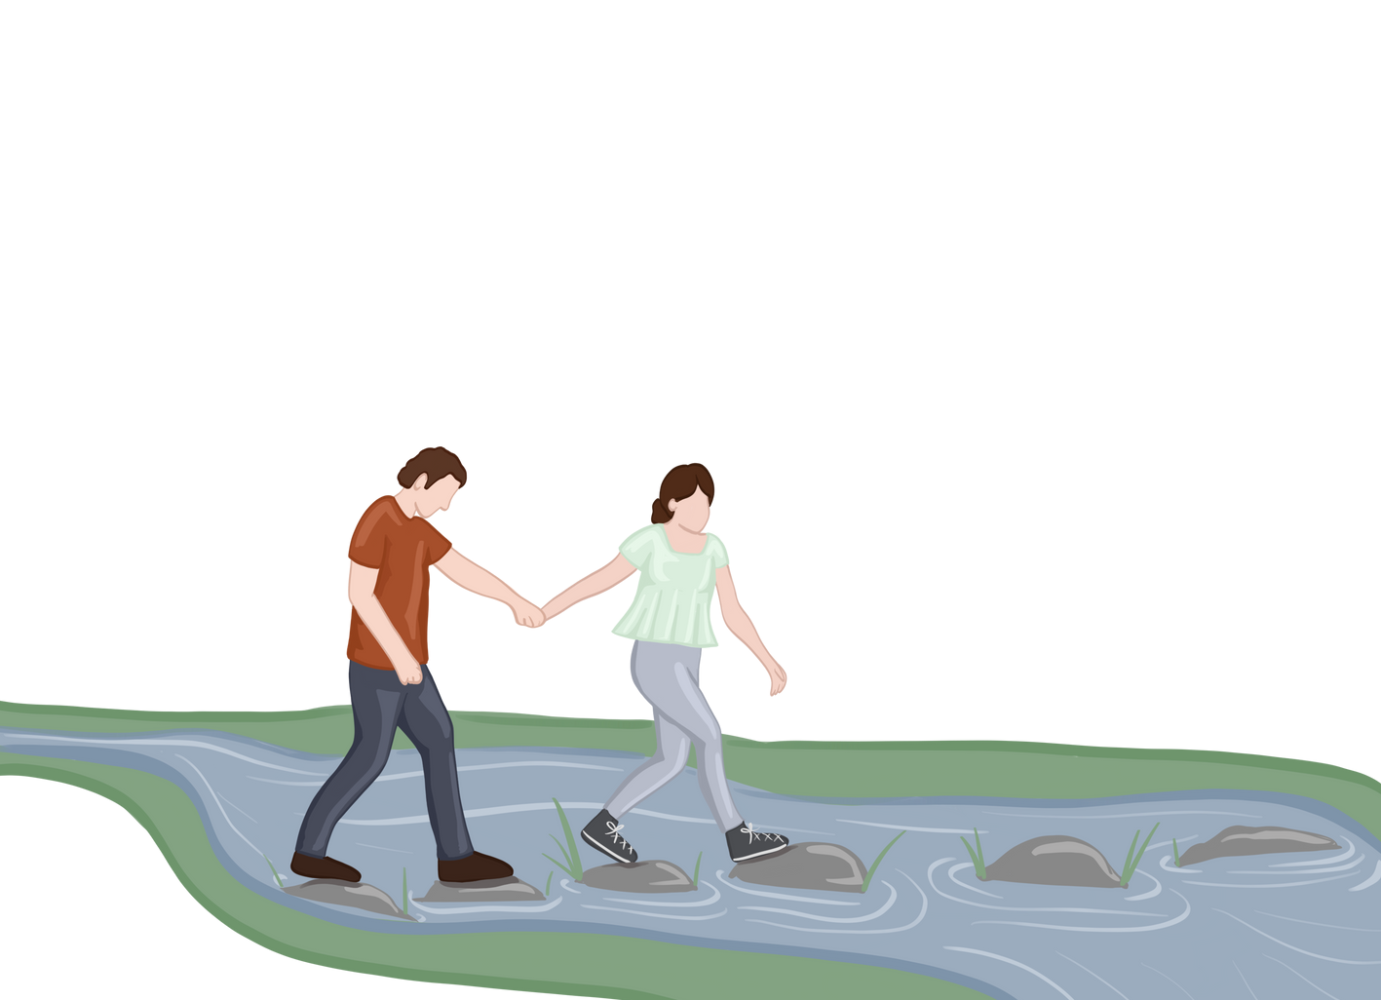

Give thanks for God’s good news to your group and to you as an individual.

Worship 2
Give everyone a candle to light from the central candle. As you each light your candle pray for a specific person to experience the light of Christ.

Word
Read Acts 13.1-3 (The Church in Antioch).
What is the Church in Antioch doing in order to discover God’s call? How does God lead them to take the next steps in mission?

Witness
Watch the Suffolk Discipleship Video here: www.lightwave.community/suffolk-discipleship- pathway or scan the QR code above. Use the Suffolk Discipleship Pathway to map your current outreach
activities and what you think God
may be calling you to next.





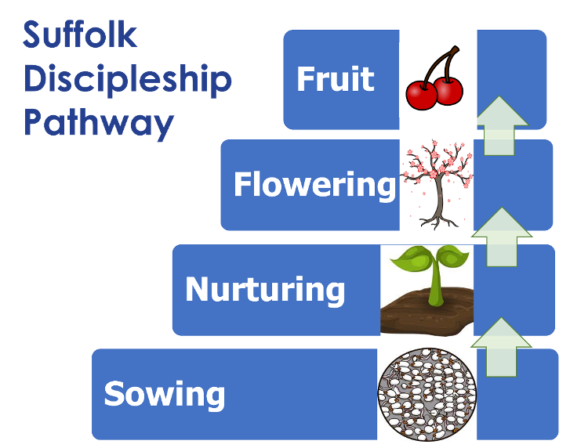




Suffolk Discipleship Pathway
The Suffolk Discipleship Pathway is a way of describing the steps most people take on their way to discovering and growing in faith. It helps churches and small groups to think about how they can be stepping stones of faith for the people they are in contact with.
The model is based on
‘Sowing, Reaping, Keeping’ - an acclaimed book by Lawrence Singlehurst and is used by
the Fresh Expressions movement in their Mission Shaped Ministry Course.

Sowing
This is the widest part of the diagram as sowing activites usually
have wide appeal... In a sowing activity, a Christian
group connects with people and shows the love of God by enjoying mutual interest or meeting a need. Its just
seeds in terms of faith- so the spiritual content of the activity may be quite small.
Some of the seeds of faith sown through this loving service germinate and the Christians involved feel that some of the people involved would appreciate an opportunity to explore or engage with faith or the Christian community, at a slightly deeper level. The arrow represents an invitation to do something more.

Nurturing
Not everyone who was involved with the sowing activity will be interested to engage with the Christian community or questions of faith, so this is represented by a smaller block than sowing.

Flowering
Opportunity to find out in depth about Christianity and to commit.

Fruit
People continue to grow as disciples within some form of Church which could be a parish church or fresh expression of Church. The word fruit conveys on-going development and giving to others in witness and service.

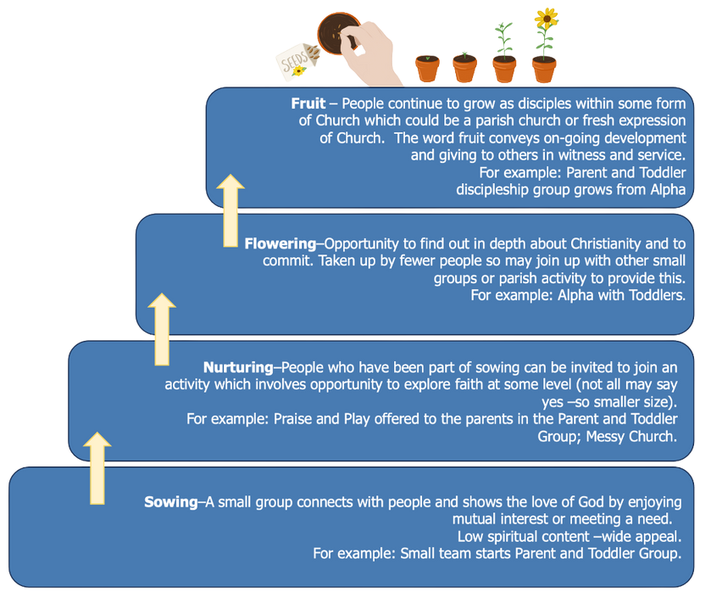











People continue to grow as disciples within some form of Church which could be a parish church or fresh expression of Church. The word fruit conveys on-going development and giving to others in witness and service. For example:

Opportunity to find out in depth about Christianity and to commit. Taken up by fewer people so may join up with other small groups or parish activity to provide this. For example:

People who have been part of sowing can be invited to join an activity which involves opportunity to explore faith at some level (not all may say yes- so smaller size). For example:

A small group connects with people and shows the love of God by enjoying mutual interest or meeting a need. Low spriritual content- wide appeal. For example:

Draw the Sowing- Nurturing- Flowering- Fruit diagram, large on a sheet of paper and use it to map your group’s outreach.

A worked example for a group whose outreach was to parents with toddlers is provided above. Think about people your group senses a call to reach out to and draw a potential pathway with those people in mind, including ideas for sowing, nurturing, flowering and fruit.

Bringing our ideas together
SMALL GROUP MEETING 5

Welcome & Worship
Drinks and brief catch up.
Remember God is with you. Thank him.
Work through the ideas which have come out so far, praying and developing them together.

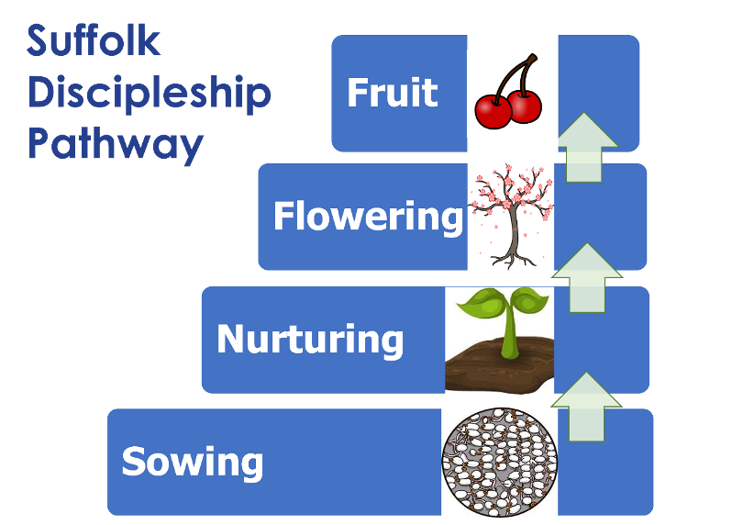



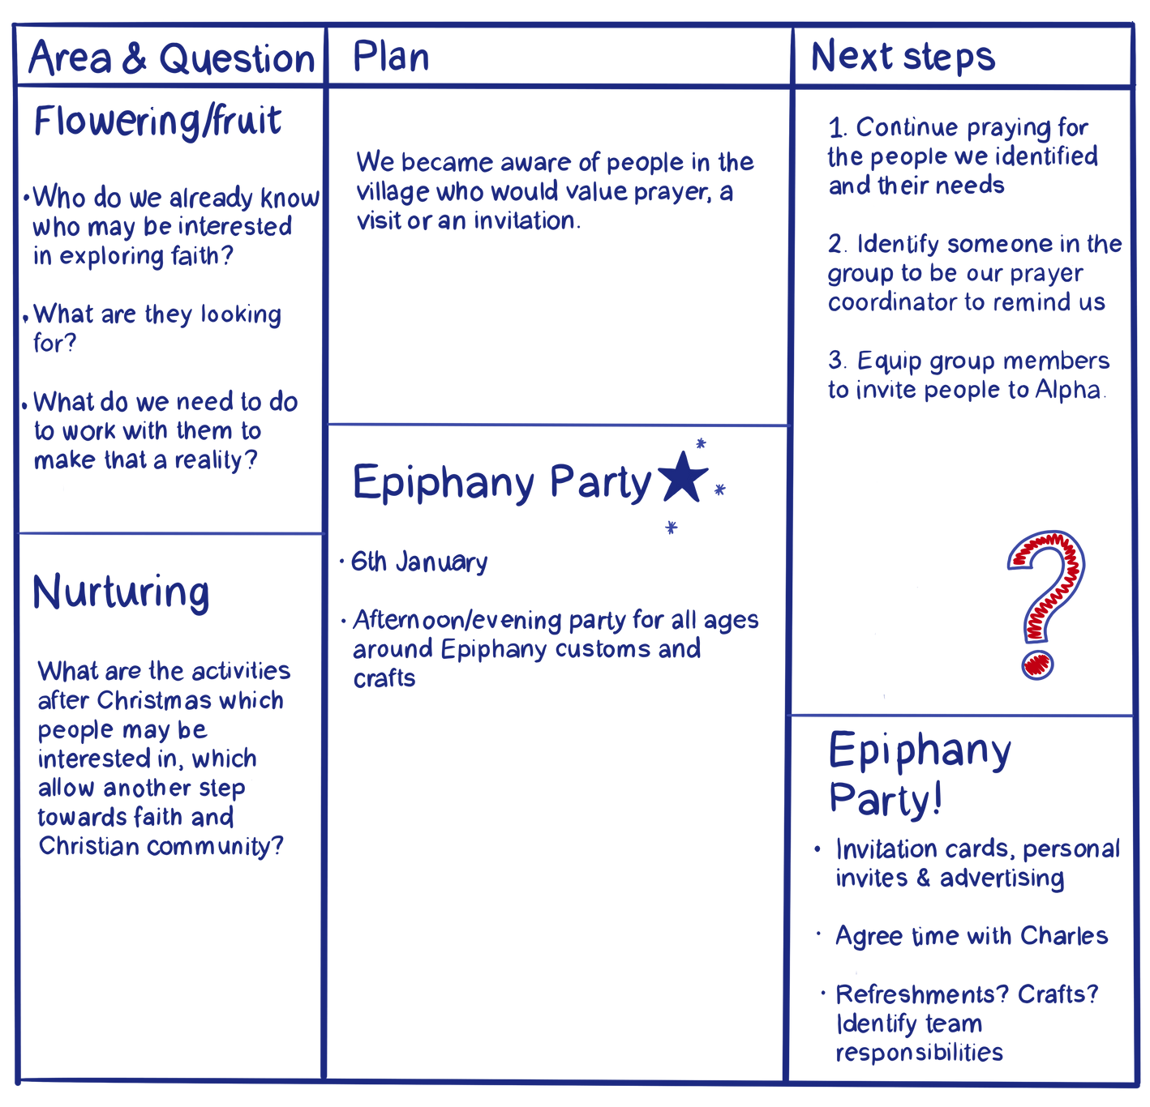

Here’s an example of how one group mapped their ideas as they approached Christmas. You can use this model if it is useful. If your minister is not part of the group, invite him/her to come to a future meeting so that you can discuss the plans and pray together.

Word & Prayer
13 “You are the world’s seasoning, to make it tolerable. If you lose your flavour, what will happen to the world? And you yourselves will be thrown out and trampled underfoot as worthless. 14 You are the world’s light—a city on a hill, glowing in the night for all to see. 15- 16 Don’t hide your light! Let it shine for all; let your good deeds glow for all to see, so that they will praise your heavenly Father.

Matthew 5.13-16


Preparing for Action
SMALL GROUP MEETING 6

Welcome
Think of an occasion when a plan did not work but when good things came out anyway. Share with the group what made the good things possible.

Word
Read Acts 13 and 14 (Barnabas and Paul’s first steps in mission).
Did everything go to plan?
How did they adjust as events moved forward?
What do you need to remember from this as you make your first steps together?
Pray for each other and about what God is saying to you.

Witness
Seek to express your vision concisely – for example fill in the Lightwave Plan for Growth and Small Group Application Form www.lightwave.community/plan-for-growth
You may wish to invite your incumbent, small group coach, Lightwave Hub Leader (or other respected Christian friend or minister on the coach/supervisor’s recommendation) to meet with the group so that he/ she can listen to what you think God is saying and to your developing plans. Encourage them to ask some hard questions and give you feedback.
Following on the feedback from your incumbent or supervisor, improve your plans as needed. You may also want to think (or think again) about:

How often does the team need to meet, to pray, worship and listen to God, to one another, and to the feedback from the people you are serving?
Who else do you want to be part of the team? Or to be involved in other ways? Do you need partners, such as other agencies or churches?
How much will this cost financially? Is a budget needed? Do you need to ask for funding – and where from?
Does the team – or individuals in it – need more training? Training in what?
Does the team need a companion who will meet with you regularly and review your progress? Who might that be?
What are your next steps? Fix dates and times, and (if needed) when and how to invite people.

Worship
Give thanks
for what you have noticed about what God is like in the past few sessions for what you have heard from God in the past few sessions
for the people you want to serve and the signs of God’s presence there
Barnabas and Paul were ‘commended to the grace of God for the work’ (Acts 14. 26). Praise God for his grace, seen in Jesus, to you and to others.
Pray for each other, for God’s grace for the work that you have planned.

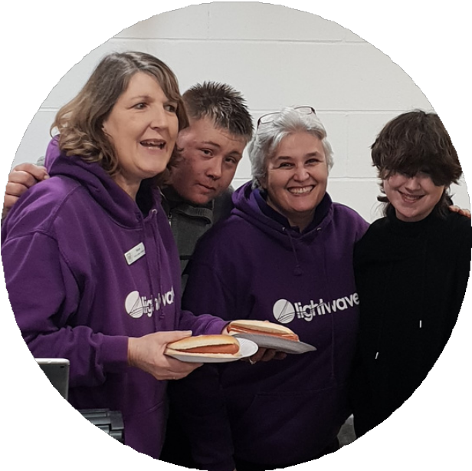


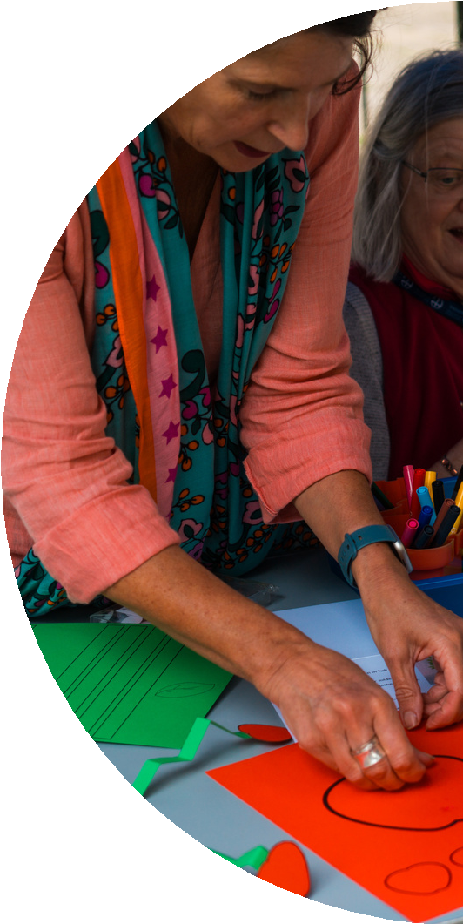
What help is available?
Lightwave would be glad to support you and talk through your unique challenges and opportunities.

Sally Gaze archdeacon.sally@cofesuffolk.org 07446933129

Diane Grano Diane.Grano@cofesuffolk.org 01638 555108

Gail Southgate

Gail.Southgate@cofesuffolk.org

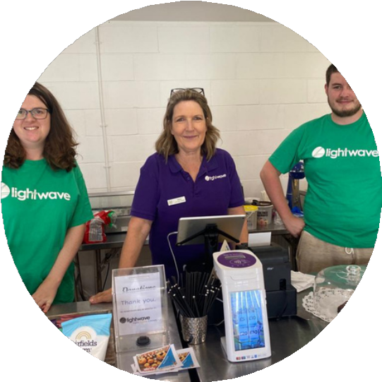


4 Cutler Street, Ipswich IP1 1UQ
St Edmundsbury and Ipswich Diocesan Board of Finance registered charity number: 143034.

